Electronics and Communication Module

Team TechKnights’ Alliance - AIITRA ‘21

# Scoring criteria :

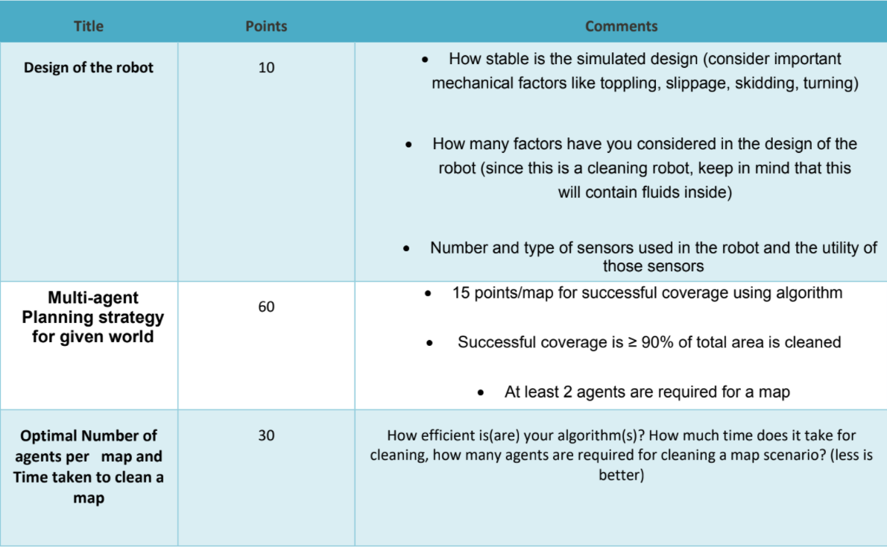

# Objectives (Module relevant) :

* Design an autonomous guided vehicle that takes inputs from a base station and navigates accordingly.
* Sense the environment around it and its own position with respect to the environment and send the necessary information to the base station.
* Equipped with the necessary electronic system that helps in cleaning task (if any).
* Establish communication back and forth with the base station

# Workflow :

| **Task** | **Date** | **Status** |
| --- | --- | --- |
| Literature Review | 23.10.21 | Started |
| Finalize all the sensors | 24.10.21 | Started |
| Finalize the microcontroller and communication system | 25.10.21 | Started |
| Navigation control techniques | 27.10.21 | Not started |

# Finalized Sensors :

| **Sensor** | **Quantity** | **Positioning** | **Utility** |
| --- | --- | --- | --- |
| IMU | 1 | Inside the Chassis | Inertial Measurement |
| LIDAR | 1 | On Top (Spins and covers 360 deg) | Environment Mapping |
| Cliff Sensor | 1 | On the bottom | To take Care of elevations |

## Component Selection : [Sensor Selection](https://docs.google.com/spreadsheets/u/1/d/1P7WQ2Freh3IO5YJaFt8dOc4V_ifWTcwW5ygwzar_Ijs/edit)

# Finalized Electronics :

| **Component** | **Quantity** | **Positioning** | **Utility** |
| --- | --- | --- | --- |
| ESP32 WROOM Board | 1 | Inside Main body | Heart of the Bot |
| DC Gear Motor | 2 | Attached to wheels | Provide torque for navigation |
| Motor Driver | 1 | Connected to ESP32 and motors | Generates input signals for motors |
| Fan | 1 |  |  |
| DC Motor | 1 | Attached to fan | To drive the fan |

## Component Selection :

[Electronics Selection](https://docs.google.com/spreadsheets/d/1UhxF3vVz84P_woB8qPkWgqJLdrKJcClQvzFFDkPBdsg/edit#gid=0)

# Finalized Power solution :

| **Component** | **Quantity** | **Positioning** | **Utility** | **Dimensions** |
| --- | --- | --- | --- | --- |
| LG HG2 18650 Battery Pack |  |  |  | Approx 15*5*5 cms |

# Project Proposal - Draft :

[Electronics and Sensors - Proposal](https://docs.google.com/document/d/17dl0S-VRhIGOtLrhZTAsKEPFq9VfwLkYcWn7M6FEM8Y/edit)